AI implementation can significantly enhance the capabilities of Descartes OCR’s Global EASE platform by making trade compliance smarter, faster, and more adaptive. Here's how AI can be woven into its existing framework:

🤖 AI Enhancements for Descartes OCR Global EASE

1. **Smarter Denied Party Screening**

AI can dramatically reduce false positives and improve accuracy:

* **Machine Learning Models** analyze historical screening data to distinguish between legitimate hits and irrelevant matches.
* **Natural Language Processing (NLP)** interprets names, aliases, and contextual data to refine screening results.
* Descartes already offers [AI Assist](https://www.visualcompliance.com/compliance-solutions/audit-and-resolution/ai-assist-for-trade-compliance/), which integrates with their compliance platform to streamline denied party screening and reduce manual workload.

2. **Predictive License Management**

AI can forecast licensing needs based on trade patterns:

* **Predictive Analytics** can anticipate which products or transactions may require licenses based on destination, classification, and historical data.
* **Automated Alerts** notify compliance teams before a license expires or when new regulations affect existing licenses.

3. **Automated Product Classification**

AI can classify goods more accurately and efficiently:

* **Image Recognition + NLP** can analyze product descriptions, specs, and even images to suggest Harmonized Tariff Schedule (HTS) codes.
* This reduces manual errors and speeds up customs filing.

4. **Regulatory Intelligence & Change Detection**

AI can monitor global regulatory databases and flag changes:

* **AI Crawlers** scan government and trade websites for updates.
* **Change Detection Algorithms** alert users to new sanctions, tariffs, or licensing rules that impact their operations.

5. **Anomaly Detection in Trade Transactions**

AI can identify suspicious or non-compliant behavior:

* **Behavioral Models** learn from normal transaction patterns and flag anomalies—like unusual routing, pricing, or partner activity.
* This helps prevent fraud and ensures audit readiness.

6. **Conversational AI for Compliance Support**

Embed AI chatbots within the platform:

* Users can ask questions like “Do I need a license for exporting lithium batteries to Germany?” and get instant, context-aware answers.
* This reduces dependency on manual research and speeds up decision-making.

**Let’s break down how AI enhances document production within Descartes OCR’s Global EASE platform—turning routine compliance tasks into intelligent, adaptive workflows:**

🤖 AI-Enhanced Document Production in Descartes OCR

1. **Predicting License Needs Before Transactions**

AI uses **predictive analytics** to analyze:

* Historical shipment data
* Product classifications
* Destination country regulations

It then forecasts whether a transaction will require an export/import license. This prevents delays and ensures proactive compliance.

2. **Classifying Products with Greater Accuracy**

AI models trained on global trade databases can:

* Interpret product descriptions using **Natural Language Processing (NLP)**
* Suggest Harmonized System (HS) codes or ECCNs
* Reduce misclassification errors that lead to customs delays or fines

This is especially useful for complex goods like electronics or dual-use items.

3. **Detecting Anomalies in Trade Patterns**

AI monitors trade flows and flags suspicious behavior such as:

* Unusual routing (e.g., a shipment detouring through a high-risk country)
* Sudden changes in buyer profiles or transaction volumes

These anomalies can indicate fraud, sanctions violations, or compliance risks.

4. **Monitoring Regulatory Changes Automatically**

AI crawlers scan global regulatory sources daily:

* Customs websites
* Sanctions lists
* Trade bulletins

When a rule changes—say, Germany updates its lithium battery import policy—AI updates the compliance logic and flags affected transactions.

5. **Automated Document Generation**

Once AI validates the transaction, it can auto-generate:

* Export/import licenses
* Customs declarations
* Screening reports
* Compliance certificates

These documents are tailored to the latest regulations and transaction context, reducing manual effort and ensuring audit readiness.

🧠 Why This Matters

AI doesn’t just make document production faster—it makes it smarter:

* **Fewer errors**
* **Faster approvals**
* **Lower risk of non-compliance**
* **Better scalability across global operations**

a **simulated AI-powered workflow** using **Descartes OCR** in a software production environment. We'll use a fictional company—**ElectroNova Pvt Ltd**, an Indian electronics exporter—trying to ship lithium-ion battery packs to Germany.

🧪 Scenario: Exporting Lithium-Ion Batteries to Germany

🎯 Goal

Ensure the shipment complies with international trade laws, generates all required documents, and avoids delays or penalties.

🤖 AI-Enhanced Workflow Using Descartes OCR

1. **Product Classification**

* **AI Action**: Scans product specs and descriptions using NLP.
* **Outcome**: Suggests the correct HS code and ECCN based on global databases.
* **Document Produced**: *Product Classification Report*

2. **License Prediction**

* **AI Action**: Analyzes destination (Germany), product type (lithium batteries), and buyer profile.
* **Outcome**: Flags the need for a dual-use export license due to EU regulations.
* **Document Produced**: *Export License Application*

3. **Denied Party Screening**

* **AI Action**: Screens the buyer against global denied party lists using fuzzy matching and contextual analysis.
* **Outcome**: Clears the buyer, logs the screening result.
* **Document Produced**: *Screening Report with Timestamp and Match Confidence*

4. **Regulatory Update Monitoring**

* **AI Action**: Detects a recent update in Germany’s import rules for hazardous goods.
* **Outcome**: Alerts compliance team and updates internal rules.
* **Document Produced**: *Regulatory Change Summary + Compliance Certificate*

5. **Document Generation**

* **AI Action**: Automatically compiles validated data into required formats.
* **Outcome**: Generates customs declaration, license forms, and audit logs.
* **Documents Produced**:
* *Customs Declaration*
* *Export License*
* *Compliance Certificate*
* *Audit Trail Report*

6. **Anomaly Detection**

* **AI Action**: Notices the shipment size is 3× larger than usual.
* **Outcome**: Flags for manual review to prevent misreporting or fraud.
* **Document Produced**: *Anomaly Alert Summary*

✅ Final Result

ElectroNova’s shipment is cleared for export with:

* All documents auto-generated
* Compliance verified
* Risks mitigated
* Audit trail ready for inspection

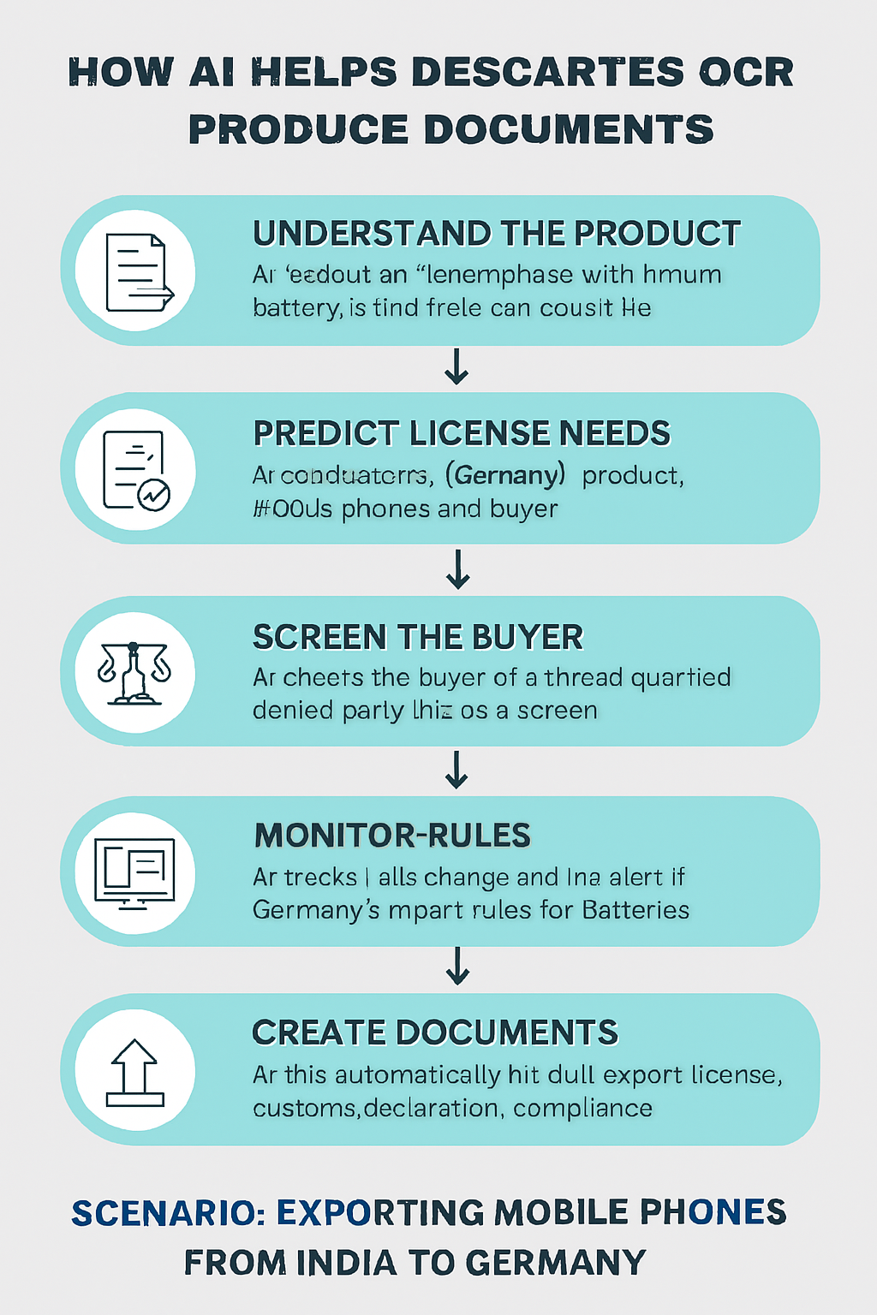

|  |  |
| --- | --- |
|  |  |
|  |  |
|  |  |
|  |  |
|  |  |

**Let’s walk through a real-world example of how AI can enhance trade compliance using a scenario inspired by** [**Global Trade Magazine’s coverage**](https://www.globaltrademag.com/how-ai-is-transforming-trade-compliance-in-a-shifting-global-economy/)**.**

🧪 Example: Exporting Lithium-Ion Batteries from India to Germany

🚨 The Challenge

A company in India wants to export lithium-ion batteries to Germany. These products are subject to:

* Dangerous goods regulations
* Export control laws (due to dual-use technology)
* EU environmental compliance
* Denied party screening for buyers

Traditionally, this would require manual classification, license checks, and screening—time-consuming and error-prone.

🤖 How AI Transforms the Process

1. **Automated Product Classification**

AI scans the product description, technical specs, and past shipment data to suggest the correct HS code and ECCN (Export Control Classification Number). This ensures accurate customs documentation and avoids misclassification penalties.

2. **Predictive License Management**

Based on destination, product type, and buyer profile, AI predicts whether an export license is needed. It checks historical patterns and regulatory updates to flag potential licensing requirements before the shipment is initiated.

3. **Denied Party Screening**

AI uses NLP to screen the buyer’s name, address, and affiliations against global denied party lists. It reduces false positives by understanding context—e.g., distinguishing between “John Smith” the buyer and “John Smith” on a sanctions list.

4. **Regulatory Change Monitoring**

AI crawls EU and Indian trade portals daily. If Germany updates its import rules for lithium batteries (e.g., new recycling mandates), the system alerts the compliance team instantly.

5. **Anomaly Detection**

AI notices that this shipment is unusually large compared to past orders. It flags the transaction for review, helping prevent potential fraud or misreporting.

✅ Outcome

* The company avoids delays and fines.
* Compliance officers spend less time on manual checks.
* The shipment clears customs smoothly.
* The system logs all decisions for audit readiness.

**Example: AI in a SaaS Accounting Platform**

⚠️ The Challenge

The company frequently updates its software to meet evolving financial regulations (like GDPR, SOX, or tax code changes). But:

* Manual compliance checks are slow and error-prone.
* Regulatory updates are hard to track across regions.
* Bugs introduced during updates sometimes go unnoticed until users report them.

🤖 How AI Solves This

1. **Automated Regulatory Monitoring**

AI-powered **Natural Language Processing (NLP)** scans government websites, legal bulletins, and financial regulations daily.

* It extracts relevant clauses and flags changes that affect the platform’s features (e.g., invoice retention policies or data encryption standards).
* Compliance teams get alerts with summaries and suggested actions.

2. **Code-Level Compliance Checks**

AI models trained on past violations and audit logs analyze new code commits:

* They detect risky patterns (e.g., hardcoded credentials, missing audit trails).
* Developers get real-time feedback before pushing to production.

3. **Predictive Bug Detection**

Machine Learning models analyze historical bug reports and user behavior:

* They predict which new features are likely to break based on complexity, dependencies, and past incidents.
* QA teams prioritize testing based on AI risk scores.

4. **Anomaly Detection in Production**

Once deployed, AI monitors logs and user activity:

* It flags unusual spikes in errors, slow response times, or failed transactions.
* For example, if a new tax calculation module causes a 20% increase in failed invoices, AI alerts the ops team instantly.

5. **AI-Powered Audit Trail**

AI automatically generates audit logs that map user actions, system changes, and data flows:

* This helps during compliance audits and internal reviews.
* It ensures traceability without manual logging.

✅ Outcome

* Regulatory updates are handled proactively.
* Bugs are caught before users are affected.
* Compliance becomes a continuous, intelligent process—not a reactive scramble.